**Microservices with Spring Boot – Account and Loan**

**1. Software Requirements**

Ensure the following software is installed:

* Spring Tool Suite (STS) or Eclipse IDE for Enterprise Java Developers
* Java 17
* Maven 3.6 or higher
* Browser (for accessing Spring Initializr)

**2. Folder Setup**

1. Go to D:\
2. Create folder with your employee ID

D:\12345

1. Inside that, create:

D:\12345\microservices

**3. Create account Microservice Using Spring Initializr**

1. Open: <https://start.spring.io>
2. Fill in:
   * **Group:** com.cognizant
   * **Artifact:** account
3. Select dependencies:
   * Spring Web
   * Spring Boot DevTools
4. Click **Generate**, download the ZIP
5. Extract the account folder into:

D:\12345\microservices

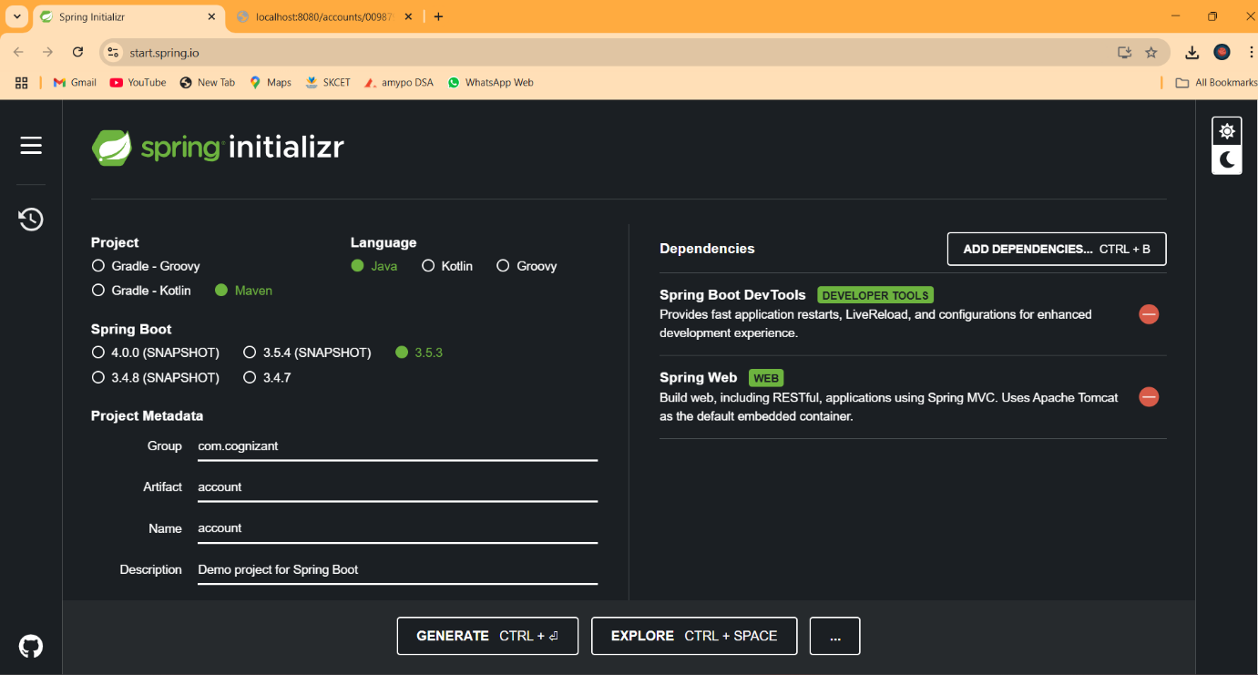

**4. Import account Project into STS**

1. Open STS → File > Import > Maven > Existing Maven Projects
2. Browse to:

D:\12345\microservices\account

1. Click **Finish**

**5. Add Controller for Account**

Create a class:  
com.cognizant.account.controller.AccountController

@RestController

@RequestMapping("/accounts")

public class AccountController {

@GetMapping("/{number}")

public Map<String, Object> getAccountDetails(@PathVariable String number) {

Map<String, Object> response = new HashMap<>();

response.put("number", number);

response.put("type", "savings");

response.put("balance", 234343);

return response;

}

}

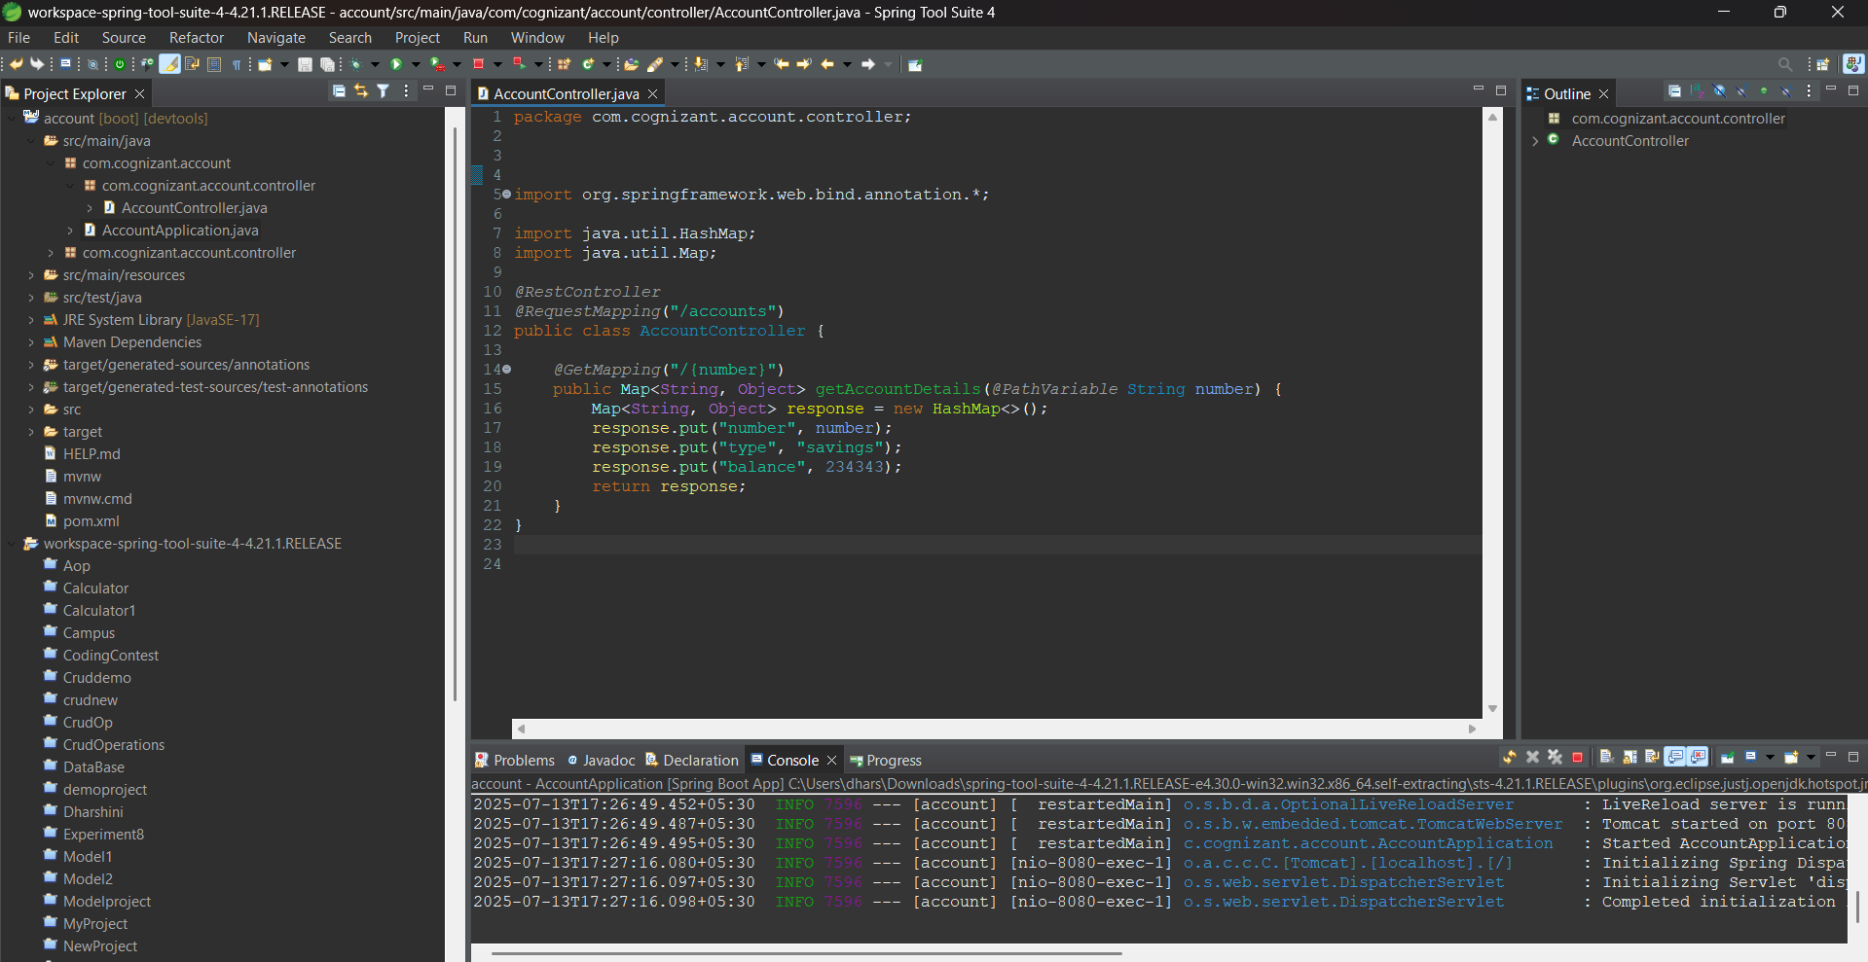

**6. Run and Test account Service**

1. Right-click AccountApplication.java → Run As > Spring Boot App
2. Visit in browser:

<http://localhost:8080/accounts/00987987973432>

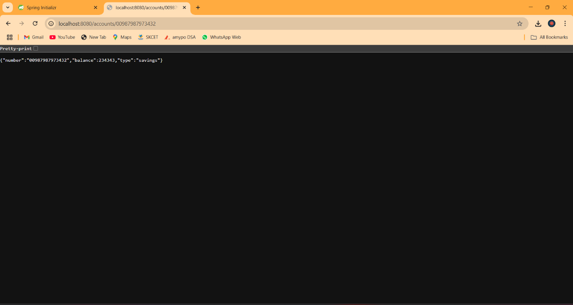

**7. Create loan Microservice Using Spring Initializr**

Repeat steps like for account, but:

* **Artifact:** loan
* **Package Name:** com.cognizant.loan
* Add same dependencies:
  + Spring Web
  + Spring Boot DevTools

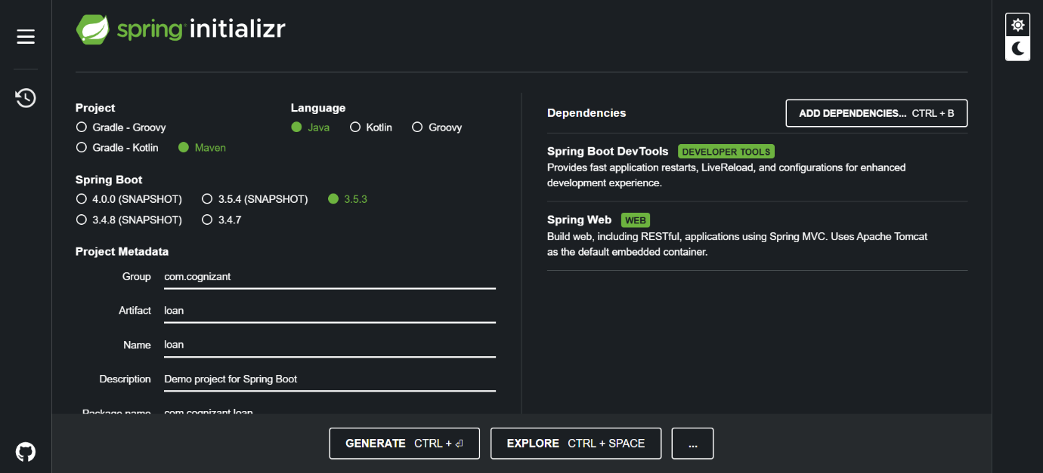

**8. Import loan Project into STS**

1. Go to File > Import > Maven > Existing Maven Projects
2. Select:

D:\12345\microservices\loan

1. Click **Finish**

**9. Add Controller for Loan**

Create a class:  
com.cognizant.loan.controller.LoanController

@RestController

@RequestMapping("/loans")

public class LoanController {

@GetMapping("/{number}")

public Map<String, Object> getLoanDetails(@PathVariable String number) {

Map<String, Object> response = new HashMap<>();

response.put("number", number);

response.put("type", "car");

response.put("loan", 400000);

response.put("emi", 3258);

response.put("tenure", 18);

return response;

}

}

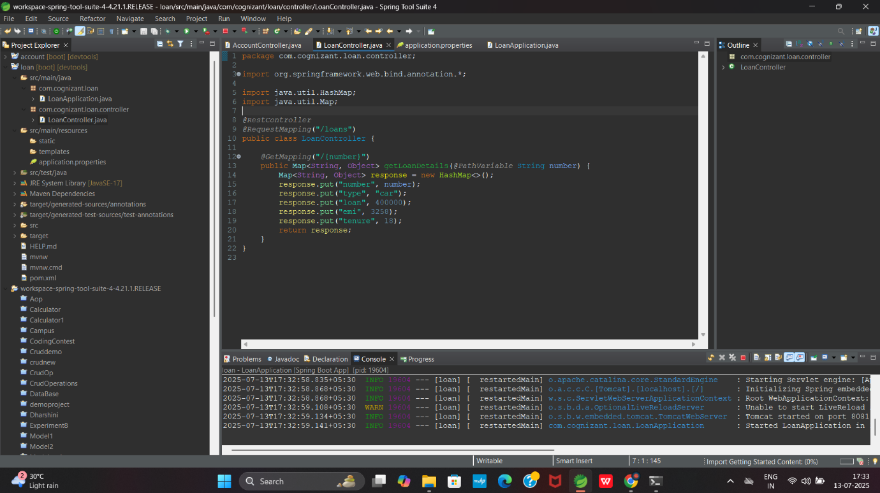

**10. Change Port for loan Microservice**

1. Open: src/main/resources/application.properties
2. Add:

server.port=8081

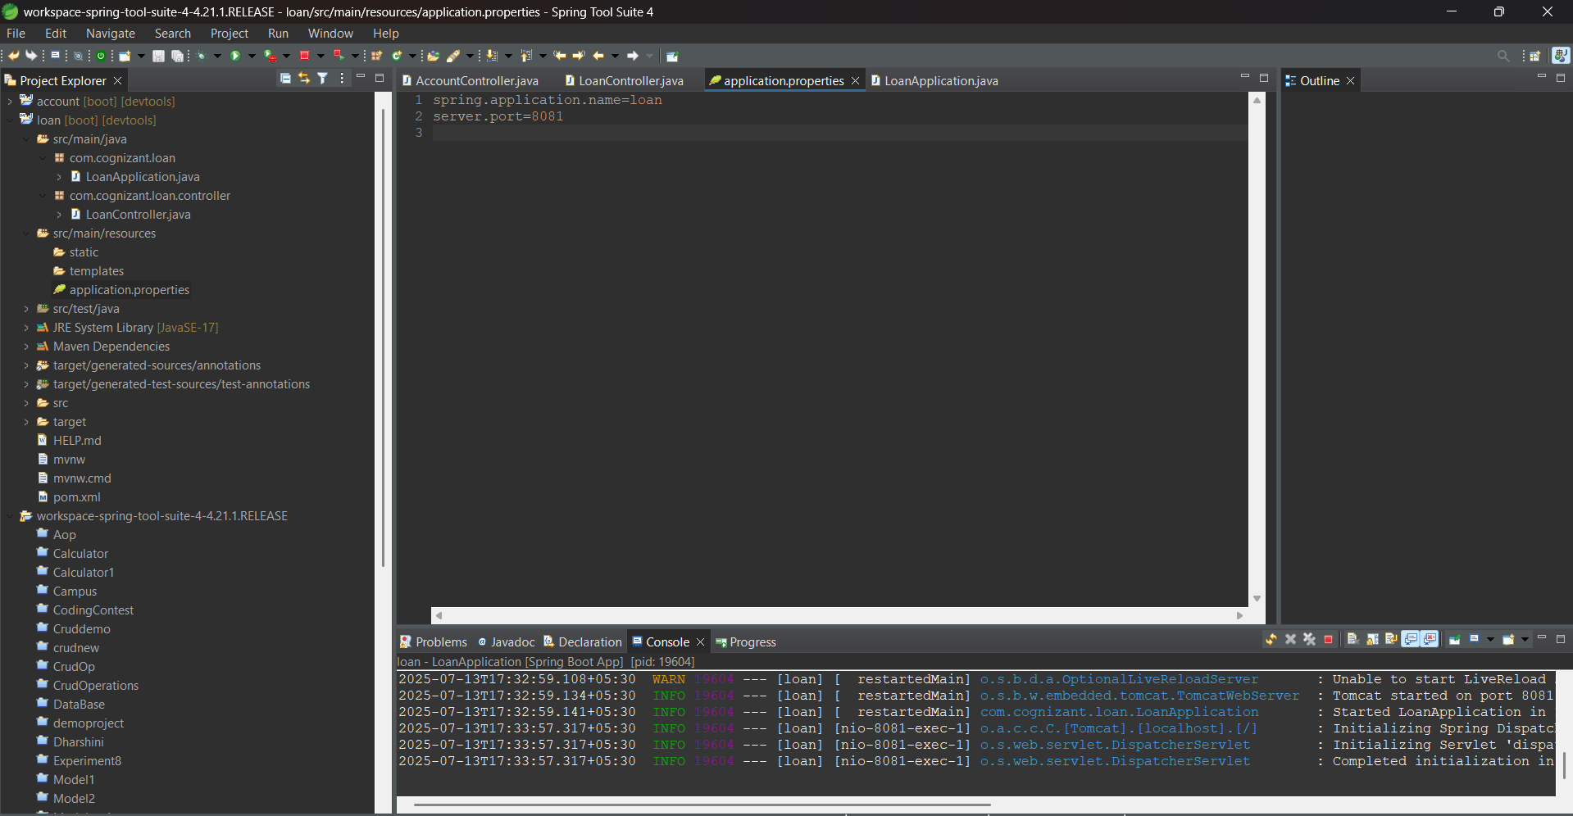

**11. Run and Test loan Service**

1. Right-click LoanApplication.java → Run As > Spring Boot App
2. Visit in browser:

<http://localhost:8081/loans/H00987987972342>

